**Topics be covered in the meeting:**

1. Overall description of the project and your responsibility.
2. What is the aspect ratio of a vertical axis wind turbine?
3. What are trailing vorticity (due to spanwise lift variation) and shed vorticity (due to orbital lift variation)?
4. How to control a VAWT? Difference between active and passive pitching.
5. What is dynamic stall: leading edge and tailing edge stall; what is double stall?
6. Directions of a airfoil: Spanwise, edgewise, flap-wise
7. What is oblique flow?
8. What is tailored airfoil?
9. Laminar separation bubble?

**Comparison of 3D aerodynamic models for vertical-axis wind turbines: H-rotor and Φ-rotor**

Questions:

1. What is velocity field: velocity field is velocity vector
2. What is the aspect ratio of a vertical axis wind turbine?
3. trailing vorticity (due to spanwise lift variation) and shed vorticity (due to orbital lift variation)
4. The 3D effects of a vertical-axis wind turbine: rotor and wake induction (this paper can be read)
5. solidity (σ = Bc/2R) (where b is no. of blades c is chord length, r is radius) of 0.085 and spins at a tip speed ratio (λ = ωR/V∞) of 3. A small solidity to represent a lowly loaded rotor with minimal wake expansion and one to represent a highly loaded rotor with large wake expansion and induction
6. Dynamic stall
7. The CACTUS fixed-wake model does account for the vortex path to a certain extend but does not account for any wake roll-up effects

Summery:

This paper investigates and compares different aerodynamic modelling techniques for VAWTs in 3D. This study presents a comparison among six models which use different formulations of the actuator and the wake/induction system. Comparisons are based on aspect ratios and solidity keeping the no. of blades and other factors constant

Limitation: this study describes comparison and explain differences based on the assumptions made by the models. However, it is not the purpose to improve the models nor to compare them to real data.

**A review of state-of-the-art in torque generation and control of floating vertical axis wind turbines**

This paper states the dynamic stall and pitching of the blades, as well as design of airfoils for VAWT applications. This article reviews and summarizes the development trends in VAWT design and control for floating offshore applications, different designs based on ingenuity and simplicity, energy effectivity, controls mechanisms and influences on COE. Five different aspects of control of VAWTs will be assessed in this review: airfoil design, the dynamic stall phenomenon, active & passive pitching of the blades, and braking/parking strategies for VAWTs

Questions:

1. wind turbine can be controlled in two ways. Pitch: pithing along longitudinal axis, lower vibration as the wind keep attached to the blade. It decreases the angle of attack. and stall: The blades and in particular the airfoils of a stall-regulated wind turbine are designed for constant tip speed ratio λ=ωR/U0 in such a way that the rotational speed ω decreases for wind speeds U0 above a certain value; stall regulated turbine causes huge turbulence at high wind speed.
2. What is oblique flow?
3. What is edgewise oscillation, flap wise direction
4. What is vortex separation
5. Leading edge and trailing edge stall
6. What is double stall, both the stall depends on thickness
7. Coriolis term
8. Stall strips and vortex generator
9. How pitching is done in vawt?
10. What is TSR, in the power coefficient vs tsr curve?
11. The main question will be “ how to control the VAWT”? active pitching and passive pitching
12. In a wind tunnel at re 1*10^6, laminar bubble/laminar separation bubble occurred. What is it?
13. What is tailored airfoil?

Cactus code: we work with

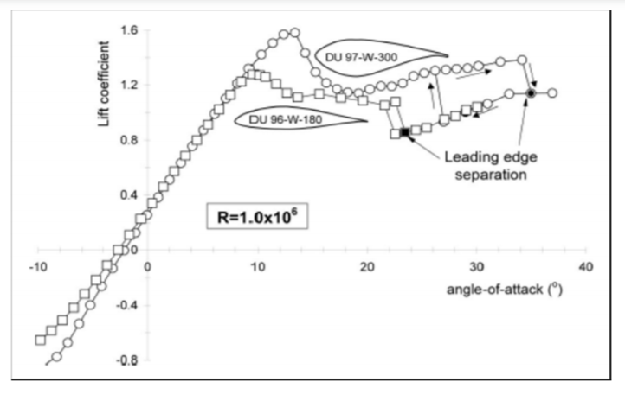

Static lift coefficients for different airfoils, obtained in LTT wind tunnel of TUDelft